Childcare Regulations 2016 – Food and drink
- A registered provider shall ensure that adequate and suitable, nutritious and varied food and drink is available for each pre-school child attending the pre-school service.

The food and drink supplied must be nutritious and should take account of the Food-and-Nutrition-Guidelines-for-Pre-School-Services as prepared by the Department of Health & Children. These guidelines advise as the following:

Children in day care for more than 5 hours per session (childminding)
We offer 2 hot meals and two snacks, for example – breakfast, snack, lunch and snack. If children are there for a long day, an evening meal is provided at 16.00.
Children in day care for up to 3.5 hours per session (sessional pre-school service)
We provide a snack for the children who attend the ECCE / Play group sessions.

Aistear – Table 1: Aims and learning goals for Well-being
The adult supports children’s psychological and physical well-being by helping them to make healthy choices about nutrition, hygiene and exercise. He/she plans for and provides opportunities for children to express themselves, to encourage them to play and work with others, and to deal with challenges. The adult also helps children towards independence by providing them with choice in their activities, and by providing opportunities for them to make decisions and to take the lead.
Aim 2
Children will be as healthy and fit as they can be.
In partnership with the adult, children will
1. gain increasing control and co-ordination of body movements
2. be aware of their bodies, their bodily functions, and their changing abilities
3. discover, explore and refine gross and fine motor skills
4. use self-help skills in caring for their own bodies
5. show good judgement when taking risks
6. make healthy choices and demonstrate positive attitudes to nutrition, hygiene,
exercise, and routine.
A Sample learning opportunity – Toddlers 2-3
The adult
■ ensures that toddlers get adequate rest, nutrition and stimulation:
➜ enables toddlers to develop and/or continue routines around eating, sleeping and hygiene, keeping their families informed of routines
➜ encourages healthy eating and helps toddlers to become aware of different food
types and their benefits, for example that milk is good for bones and teeth, and
that fruit and vegetables are good for healthy bodies
➜ incorporates sleeping times into the daily routine for those who need it
Siolta: Component 9.4 Our setting is proactive in supporting the development of healthy eating habits in children whilst supporting their enjoyment and appreciation of eating as a positive social experience.
At Ulla Beag – all meals are prepared in house by Denise Sheridan ( dip in Children’s Nutrition). Fruit and veg are part of the daily diet in line with the Food Pyramid and meat; fish ; chicken and meat alternatives ( soya) are part of the weeklyhealthy meal planner. Sample attached. We grow with the children in our school garden ; collect eggs from our chickens and plant, harvest and share plants with home to create a holistic transition in understanding and experience for the child’s experience with nutrition and healthy eating.

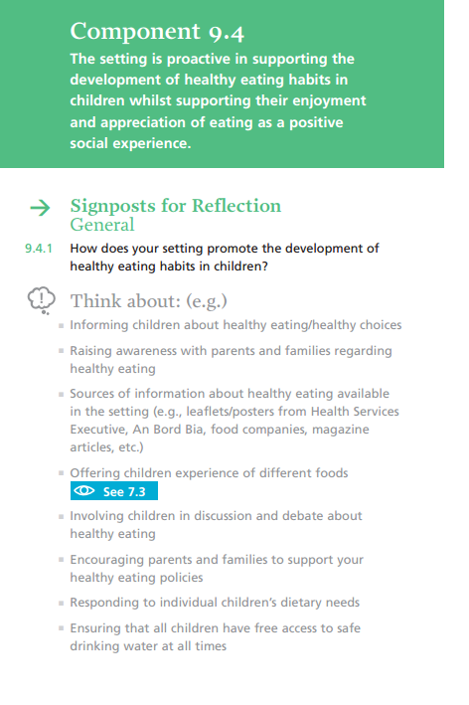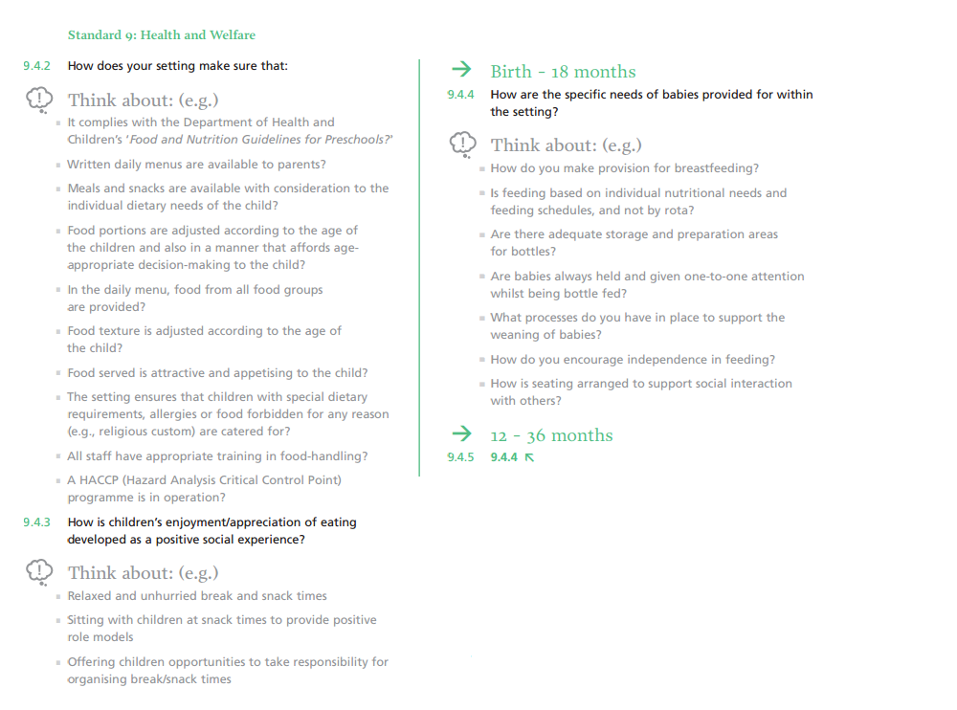

Two Week Meal Planner:

