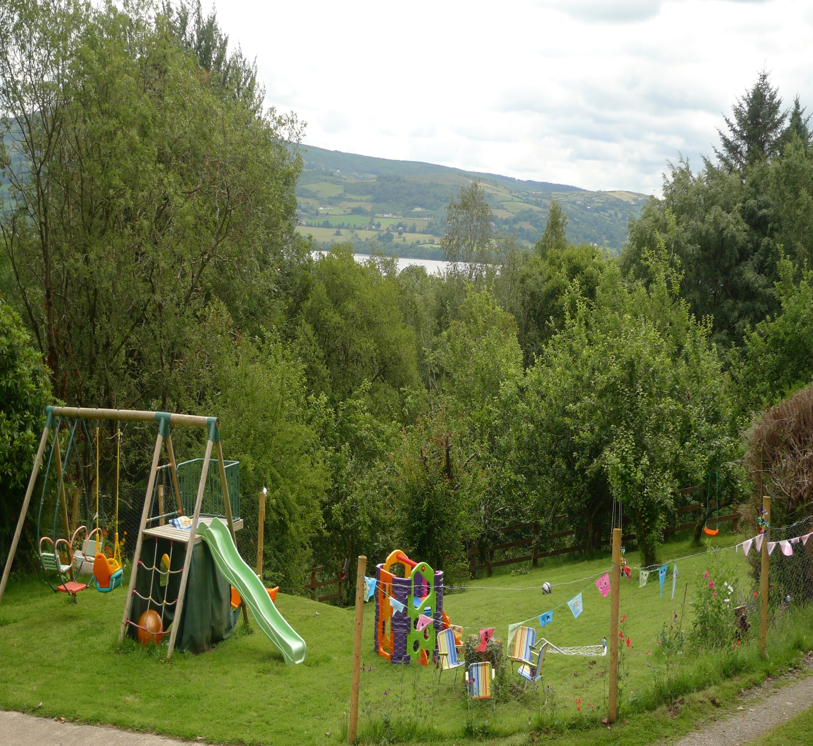
Parent Handbook

Supporting and Delivering Rural Development through the provision of Childcare and Community Services.

Úlla Beag Philosophy
Our Philosophy......so what are we about.??....
At Úlla Beag we focus on age appropriate activities which enhances social interactions for children.
When play and materials are age appropriate for the child, stress levels are lower, there are less arguments and social interaction is enhanced.
A Child’s brain needs an abundance of creative play opportunities to develop.
We will provide a structured day full of learning experiences allowing your child to explore through creative play. Our Preschool program of activities is based around creative play activities.
Some examples......
- Kiddie Hopscotch.... I have experienced a game of hopscotch where everyone played their own way at the same time ...a lot more efficient then waiting your turn!

- Colouring with crayons on plain paper and allowing the child to develop their sense of what the world looks like to them. I know a certain little girl who has only now started to draw arms on her stick people because she did not want to until now. She has been however drawing everyone in running shoes for the last 6 months!

- Wooden Blocks, . the sky is the limit.

- Muddy puddle painting.... blobs of paint on a large sheet of paper and what’s next ....

- Fairy tale role play, story telling and dress up to their own script

- Hosting their own puppet shows.

- Playing music and providing different props for children to use to move or dance

- Learning Yoga which is a lifelong journey ( it still amazes me how flexible my daughter is with yoga moves when I struggle now with the same ones! I came to yoga later in life!)

- Learning counting through gardening and song.

- Fun Cooking and easy baking

- Planting through the seasons
In our After School club we will provide time for homework and then move on to more creative activity around a theme of projects :
- T Shirt design
- Creative Story Telling
- Creative Writing
- Project researches on the web
- Garden plotting
- Outdoor play

We will support the activities through interactive white/ smart board technology where appropriate –example researching how people manage in drought ridden countries to conserve water. We have an underlying theme throughout our services and that is to build sustainable living skills.
Sustainable Living Focus :
- For recycling we will use cardboard, toilet rolls, plastic bottles etc as art supplies and in our make and do.
- We will manage our energy use by learning how to conserve rain water; turn off lights, taps etc.
- By teaching gardening as part of the overall curriculum we will introduce and build on skills that children can take with them throughout their life and we will all enjoy their journey on the way.
I had a very interesting experience with my daughter when planting sugar peas. We both went along dropping peas as we went – mine had a definite path to follow and I could see Ruby had clusters in different areas. About 3 days later I also discovered a pot with a handful of soil and about 40 peas in it.
We rescued them and planted them in 2 bright pink tubs which Ruby has picked out and now we have a second and third harvest of peas coming through. I must say by now though the excitement of the peas has worn off Ruby!
Following the Síolta Quality Framework and Aístear Early Education Curriculum we place a huge importance on parental involvement and choice within early years development. We treat evey child as an individual and will work with you on learning plans tailored towards your child’s cognitive and developmental needs.

Mission
The purpose of this booklet is to provide you with the information around the programs and activities in which your child will take part.
We aim to provide an experience that will leave you and your child with happy memories and skills which can be taken with you....
We provide a family run, safe, collaborative environment
We foster a creative learning environment where each child can become self confident and an independent being.
By providing your child with a social environment where she/he can interact with other children and the staff within Úlla Beag , we facilitate the beginning of relationships away from the family unit.
As a home away from home the child can work at her / his own pace and enjoy social interactions within their own age group.

Úlla Beag Parent and Toddler Group
We meet once a week every Friday 11.00-12.30.
We have a separate play area for the toddler group full of toys for loads of fun!
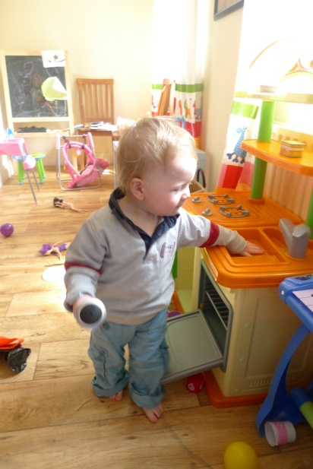
Sessions cost €2 per child, €1.50 per adult.
Babies (under 1) can be accommodated and are free of charge
This covers tea / coffee and homemade bread / scones for the adults and juice, milk or water and biscuits for the children.
For 2 or more children the session will cost €3.For 2 parents the session will cost €2.
We have a great range of toys and do song time at the end of the session.
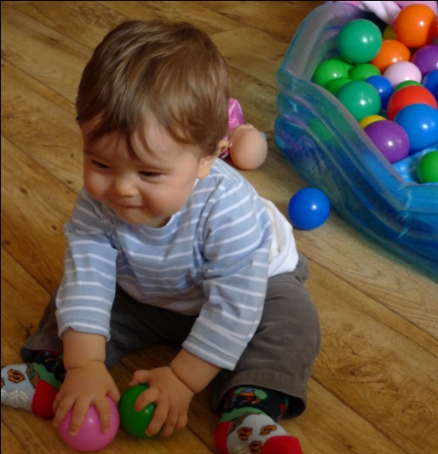
We also have full use of the gardens and lots of outdoor toys when the weather is good!
We are a registered Big Toddle Group with Barnardos and will host our first Toddler event on the Sunday 26th September. This is sponsored by Danone and all funds raised go directly to Barnardos.
We will be holding regular toddler/ family fun events so keep your ideas rolling in to us.
Pre-booking essential please!

Preschool Program 2-5 year olds
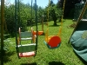
We are an ECCE participant.
Who can attend:
Children who have reached the age of 2 by the 1st Sept in the current program year.
Children must be toilet trained.
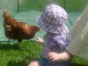

Hours : Mon – Fri 09.30-12.30.
Class Size : The maximum number we will take into this class is 12.
There will be a qualified Childcare Supervisor and Classroom Assistant for the class.
The Costs :
There is a €22.50 euro registration fee. This is non refundable and covers the cost of materials and personal accident insurance for the school year.
Preschool Fees-
Weekly : €63.50. /Daily €13 / Hourly €5.
Weekly & Daily rates will be paid at the beginning of every week or month. Places will be secured at the beginning of the school term.
Hourly rates will be managed as follows :
- Scheduled hourly rates - will be secured at the beginning of the school term.
- Drop in Facility – we will operate a drop in policy however due to limited spaces pre booking will be essential.

Program Samples

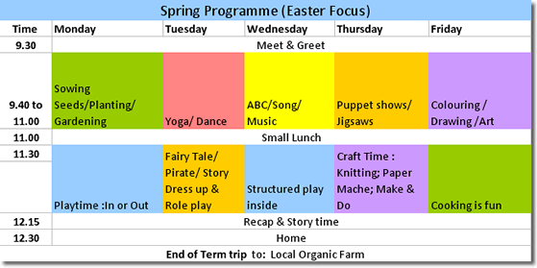

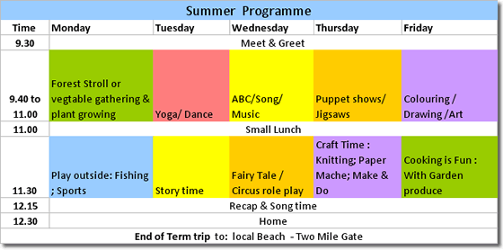

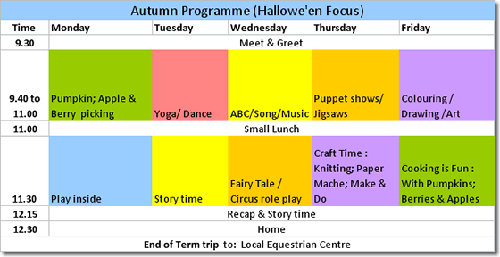

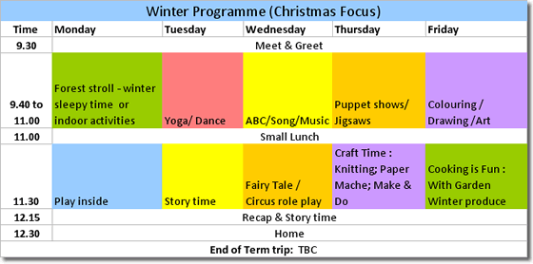

B: After School Program
Who can attend: Children from Juniors through to Second Class in National School. For the convenience of the family we can accept older siblings and will agree this individually with the parents.
Hours : Mon – Fri 13.30 – 16.30.
Class Size : The maximum number we will take into this class is 12. There will be a qualified Childcare Supervisor and Classroom Assistant for the class.
The Costs :
There is a €22 euro registration fee. This is non refundable and covers the cost of materials for the year and personal accident insurance for the school year.

There is an hourly rate of €9 for the after school program.
For up to 3 hours for the week we will charge €9 an hour.
From 4 – 6 hours for the week we will charge €8.50 an hour.
From 7-15 hours for the week we will charge €7.50 an hour.

I can also offer a reduced sibling rate please contact me for further details,

- Spring , Summer & Autumn Activity Camps.
2011 :We will hold camps as follows throughout the year.
For any children enrolled in the preschool or after school in 2010/2011 we will apply a 5% discount on the above rates.

- Family fun days
Community and Family fun days
Our two supported Charities which we will organise events for during the year are Barnardos and Breast Cancer.
Our first event has been scheduled for the 26th September 2010 for the Big Toddle with Barnardos, sponsored by Danone.
Our first event to Support Breast Cancer charities will be held as a Pink Picnic in early spring. Details to follow….
NALA Support trainer
I am aiming to have completed my NALA tutor training by Dec this year with the aim of providing 2-3 hours support per week once qualified.
In time I would see Úlla Beag providing a secure localation for a NALA group setting.
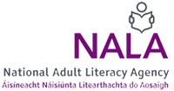By leading by example in sharing my time to help others I want to build a network of people who wil do the same once we have a shared vision, which will build community spirit and provide help to others at the same time.

Further Education
We will be providing a range of night classes and further education services starting in Spring 2011.
These will include :
Yoga Classes;
Art Classes;
Language Classes;
Business Support Classes;
Computer Skills Classes.
I will be working with trainers , tutors and subject matter experts in the local area of Ogonnelloe, Killaloe and Ballina.

We will also be launching a study tips section to our website to help studens of all ages in Summer 2011.

Art Therapy at Úlla Beag
Art Therapy provides a much easier way of expression for children.
Children are more creative and artistic naturally.
For children who have limited language or a young trauma survivor who may be unable to put ideas into speech, expression through art and play can be ways to convey oneself without words and may be the primary form of communication in therapy.
It is a therapeutic means of reconciling emotional conflicts, fostering self-awareness, developing social skills, managing behavior, solving problems, reducing anxiety, aiding reality orientation, and increasing self-esteem.
Art therapy has been used successfully with Children who
- have learning difficulties;
- have autism;
- suffered a trauma;
- suffered a bereavement;
- suffering from cancer.
and many more examples can be found.
From Autumn 2012 we will be offering art therapy counseling for children.
More to come nearer our launch date.

General Information :
A Parent – Child Orientation Session will be held for each class 1 week before school begins.
School Calendar : The School year will begin on the 6th September 2010.
A Calendar of events for the whole year will be handed out during the orientation session.
Curriculum: We will follow the Aistear Early Childhood education principles and guidelines as put forward by the OMCYA - Office for the Management of Child & Youth Affairs.
Our Quality framework is based on the national Síolta Quality Framework.
During the year the program will be closely linked to the seasonal changes of the outside world.
The areas covered in the program will include:
- Daily organized lessons on the activity for each class.
- Art & Crafts
- Free Play
- Outdoor garden activity
- Story telling/Role Play /Group Play
- Music time
- Educational Games, Songs & Stories
- Activities for small and large motor skills.
- Counting 1-10 and beyond
- Holiday specific programs.
- Yoga, Dance & Movement
- Basic Cookery Skills
- Reuse , Reduce Recycle
- Age appropriate computer skills.
Quality Assurance : We will apply the Síolta Quality Framework. Please find some information on this here and also link to the Síolta Website.

Complimentary Services
1. Parent website log on
- Secure log on facility for you to view information, photos etc. on the sessional activities.
2. Juices and snacks for After School & Preschool ( where requested).
- We supply organic apple juice, homemade bread and jams and seasonal fruits and vegetables as snacks during the afterschool session and where requested this can be provided for our preschoolers.
- All are sourced from our neighbouring market gardening family at www.goodandgreen.ie.
- Hot meals can be made available for the after school club please discuss your requirements with me directly. The menus will be organic as much as possible and based on seasonal availability of produce.
3. Any surplus vegetables and fruit from our own garden we will happily send home to you.
4. Monthly newsletter :
- What’s happening now….(this will be available on a monthly basis via our website)
5. A complimentary start of term T- shirt from Úlla Beag with your child’s name embroidered on it. So enrol quickly as I will need to start stitching.
6. Daily report updates – we will discuss daily with you how your child’s day was and provide a weekly written summary for you.

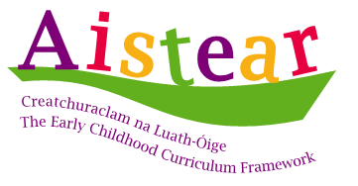
Aístear Early Education Curriculum

Principles of early learning and development
Aistear is based on 12 principles of early learning and development. These are presented in three groups:
1. The first group concerns children and their lives in early childhood:
- the child’s uniqueness
- equality and diversity
- children as citizens.
2. The second group concerns children’s connections with others:
- relationships
- parents, family and community
- the adult’s role.
3. The third group concerns how children learn and develop:
- holistic learning and development
- active learning
- play and hands-on experiences
- relevant and meaningful experiences
- communication and language
- the learning environment.

Drop off / Pick up Students:

At Arrival : Parents will drive into the car park and bring the child to the preschool door.

At Departure : The parent will pick up the child at the agreed time.

Please be on time to pick up your child. We can only release your child to you or your designated pick up person who is on our notified list.
We will not be able to release children to adults who have not been previously agreed as pick up persons.

Snacks: HSE guidelines

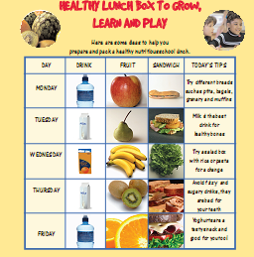

Show and Tell will be held every Friday where the child can bring a favourite book or toy to share with the class.

Clothing :
A Personalised T Shirt will be supplied to each child registered at the start of the school term.
Please provide adequate outdoor wear to keep your child warm during outdoor play. We encourage you to dress your child in clothing which is easy for the child to manage in the bathroom. For your child’s safety, totally closed shoes are highly recommended.

Discipline:
Our policy is to apply a positive Behaviour/Behaviour Modification Model. Positive reinforcement verbally praises actions and skills that the child is doing well. When other children hear praise they will also modify their behaviour to get praise.

Illness:
If you suspect your child has an infectious disease they should be kept at home. The following are a list of childhood diseases and how long the child must remain out of school. These are the World Health Organisation guidelines :

Chicken Pox - 6 days after appearance of the crop of pox.
Strep infection/ Tonsillitis - 7 days from onset or 24 hrs after an antibiotic has been administered.
Head Lice – Until judged by the doctor as no longer infective.
Influenza – Until fully recovered.
Conjunctivis – 24 hours after institution of appropriate therapy.
Skin infections – Crusty Sore , Scabies – itch, Ringworm – until judged y the doctor as non infective.
Whooping cough – 4 wks from onset or or 24 hrs after an antibiotic has been administered.

Contact us :

Contact Us
Úlla Beag
Ballybroghan
Ogonnelloe
Co Clare
Tel: +353 (0)85 7283333 begin_of_the_skype_highlighting +353 (0)85 7283333 end_of_the_skype_highlighting
Email: info@ullabeag.ie
Website: www.ullabeag.ie

